Methodology
The model predicts cancer survival by combining different types of patient data using deep learning.

1. Learning from Each Data Type
Each patient has different data types:
- Clinical data
- mRNA
- miRNA
- CNV
Each type is passed through its own neural network:
$h^{(k)}$ = $f_{k}$($x^{(k)}$)
This means:
- Each network learns important features from its own data
- Output = a feature vector (representation)

2. Making Features Similar (Siamese Loss)
Since all data belong to the same patient, their features should be related.
So we minimize the distance between them:
L_{sim} = || $h^{(1)}$ – $h^{(2)}$ ||²
This helps:
- Different data types “understand” each other
- Improves consistency

3. Combining Data using Attention
Not all data types are equally important.
The model gives weights (importance) to each one:
α^{(k)} =$\frac{e^{(k)}}{\sum{e^{(k)}}}$
Then combines them:
h_{fusion} = $\sum{α^{(k)}h^{(k)}}$

So:
- Important data gets more focus
- Less useful data gets lower weight

4. Predicting Survival (Cox Model)
The combined feature is used to predict a risk score:
r = g($h_{fusion}$)
The model is trained using Cox loss:
L_{cox} = $-\sum{(r_{i}}-log\sum{e^{rj} )}$
This means:
- Higher score = higher risk
- Model learns who is more likely to survive longer

5. Final Loss

L = L_{cox}+ λL_{sim}
Combines:
- Survival prediction
- Feature consistency

Algorithm:
1. Deep Neural Networks (DNNs) -Used to learn features from each data type (clinical, mRNA, miRNA, CNV) Each data type has its own network Converts raw data into useful information.
2. Siamese Loss -Makes features from different data types of the same patient similar Helps the model understand that all data belong to one person.
3. Attention Mechanism -Decides which data is more important Gives higher weight to useful data Gives lower weight to less important data.
4. Feature Fusion -Combines all the data into one final feature Uses attention weights to merge them.
5. Cox Survival Model -Predicts survival risk Output is a risk score (not exact time) Higher score = higher risk
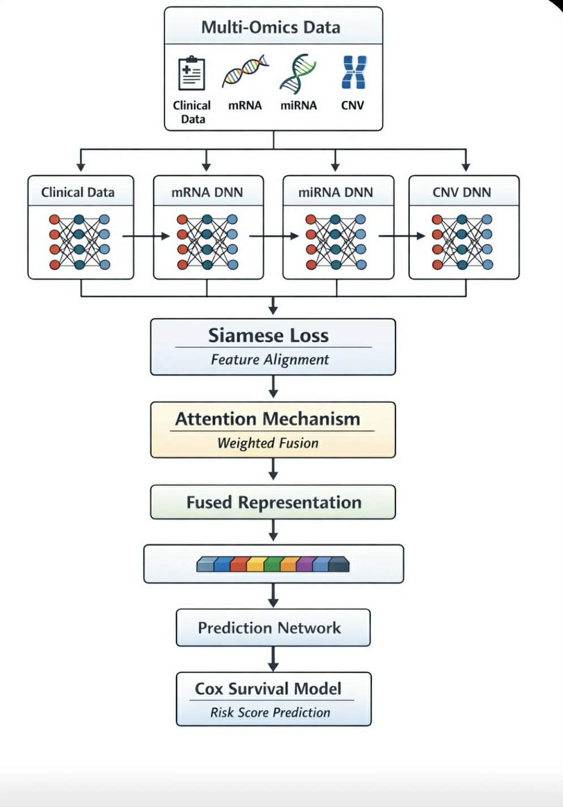
6. Backpropagation (Training) -Updates the model to improve accuracy Uses loss functions to learn better.

